Probabilistic Inventory Models

Marginal cost of surplus per unit C1=purchase cost -salvage value

Marginal cost of shortage per unit C2=selling price - purchase cost

Let generalized probability distribution of the demand of the items be a discrete distribution as

|  |  |  |  |  |  |
| --- | --- | --- | --- | --- | --- |
| Observation | i | 1 | 2 | … | n |
| Demand | Di | D1 | D2 | … | Dn |
| Probability | Pi | P1 | P2 | … | Pn |

The optimal order size Di is determined by the relation

$$P_{i-1}<\frac{C_{2}}{C_{1}+C_{2}}{<P}_{i}$$

Q1: the daily demand of bread at a bakery follows a discrete distribution as follow:

|  |  |  |  |  |  |  |  |  |  |  |  |
| --- | --- | --- | --- | --- | --- | --- | --- | --- | --- | --- | --- |
| S No. | 1 | 2 | 3 | 4 | 5 | 6 | 7 | 8 | 9 | 10 | 11 |
| D | 25 | 26 | 27 | 28 | 29 | 30 | 31 | 32 | 33 | 34 | 35 |
| P | 0.2 | 0.11 | 0.1 | 0.09 | 0.08 | 0.12 | 0.14 | 0.05 | 0.04 | 0.04 | 0.03 |

The purchase price of the bread is Rs. 8 per packet. The selling price of the bread is Rs. 11 per packet. If the bread packet nit sold within the day of purchase, they are sold at Rs. 4 per packet to hotels for secondary use. Find the optimal order size of the bread.

Solution:

purchase price of the bread is Rs. 8 per packet

selling price of the bread is Rs. 11 per packet

salvage price of the bread is Rs. 4 per packet

Marginal cost of surplus per unit C1 = 8 – 4 = 4

Marginal cost of shortage per unit C2 = 11 - 8 = 3

Therefore, cumulative probability

$$P=\frac{3}{4+3}=0.43$$

Now we find the cumulative probability of demand.

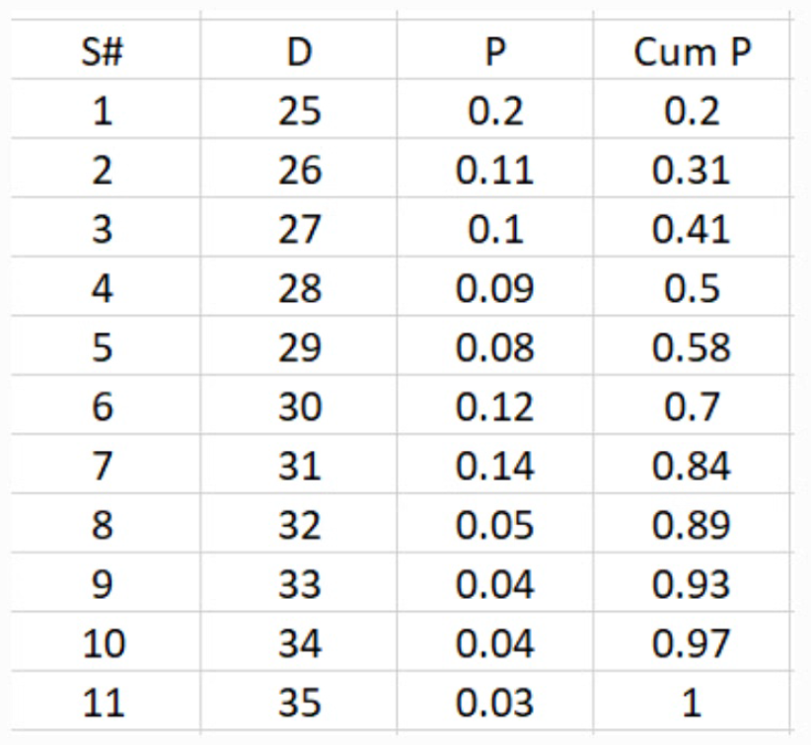

From the table it follows that

$$P_{3}<\frac{C_{2}}{C_{1}+C_{2}}=0.43{<P}_{4}$$

$$0.41<0.43<0.5$$

Therefor, the optimal order size is D4 which is equal to 28 breads

Q1: A probability Distribution of monthly sales of a certain item is as follows.

|  |  |  |  |  |  |  |  |
| --- | --- | --- | --- | --- | --- | --- | --- |
| Monthly Sales (r) | 0 | 1 | 2 | 3 | 4 | 5 | 6 |
| Probability P(r) | 0.02 | 0.05 | 0.3 | 0.27 | 0.2 | 0.1 | 0.06 |

The cost of carrying inventory is Rs. 10 per unit per month the current policy is to maintain a stock of four items at the beginning of each month. Assume that the cost of shortage is proportional to both time and quantity, obtain the computed cost of a shortage of one item for one unit of time.

Sol:

C1= Rs. 10 per unit per month,

Q = a stock of four items = 4

Since the demand is uniformly distributed over the month, the least value of shortage cost C2 can be determined using the relation.

$\sum_{r=0}^{Q-1}{P\left(r\right) }+(Q-\frac{1}{2})\sum_{r=Q}^{∞}{\frac{P(r)}{r}}$ $≤\frac{C_{2}}{C_{1}+C_{2}}≤\sum_{r=0}^{Q}{P\left(r\right) }+(Q+\frac{1}{2})\sum_{r=Q+1}^{∞}{\frac{P(r)}{r}}$

LHS=

= 0.92=

C1=10

C2=115

RHS=

= 0.975=

C1=10

C2=390

115390